**KICKSTARTER Campaigns Analysis Report**

Conclusions

Limitations of the dataset

Other possible tables/graphs

Summary Statistics

**Conclusions:**

1. Based on the categories of campaign offered by Kickstarter, categories like Film/Video, Music, Technology and Theater have more successful outcomes as compared to other categories.

* The category with more campaigns is “Theater” with 1393 campaigns.
* The category with more successful outcome is “Theater” with 839 successful campaigns. The sub-category “Plays” are more successful.
* The category with more rate of success is “Music” at 77%. All 260 campaigns related to sub-category “Rock” are successful.
* The category with more rate of failure is “Food” at 70% out of 200 campaigns with “Small batch” being the only successful sub-category.
* The category with minimum campaigns is “Journalism” with 24 campaigns (noticeably all got cancelled).

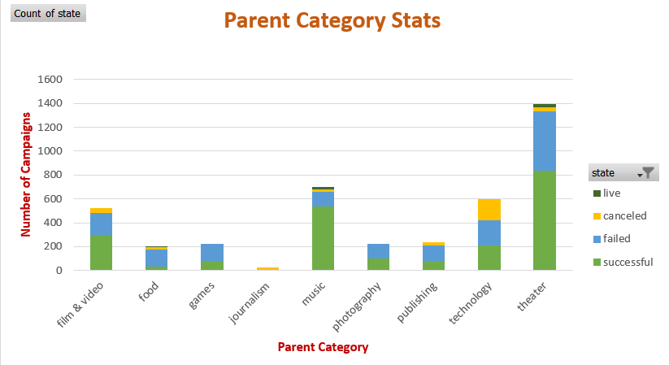

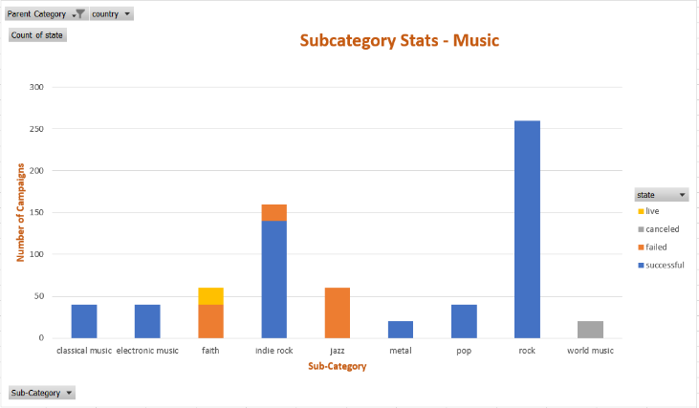 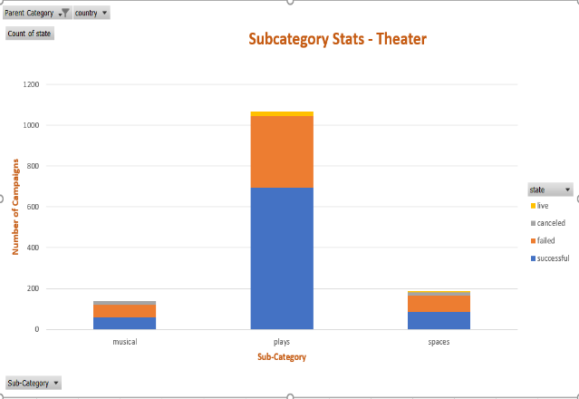

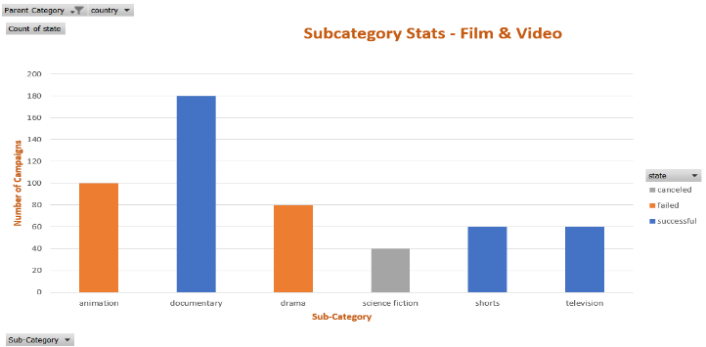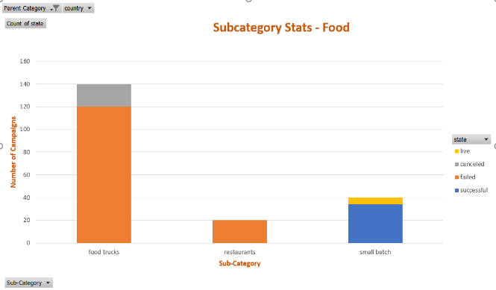

2. Another trend can be found is with respect to the goal that is set. Based on the data, lesser the goal amount, more successful are the campaigns.

* With 1865 campaigns in the range 0-$4999, has the best success rate of 67%.
* With 444 campaigns having goal more than $50,000, has the least success rate of 19%.

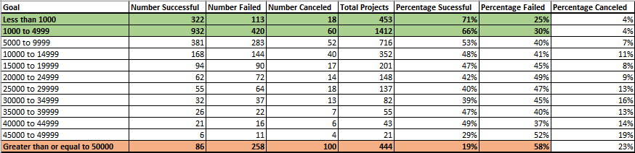

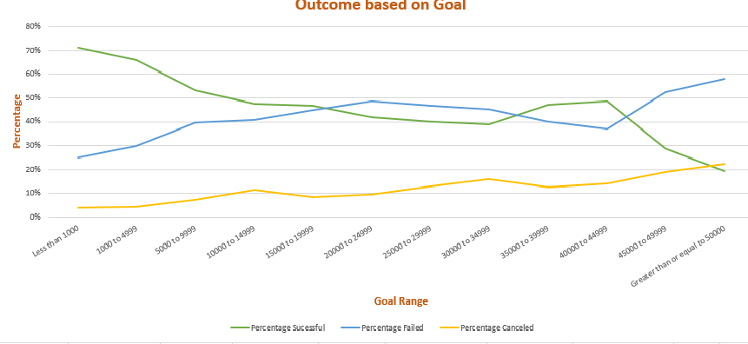

The percentage of success is dependent on the goal amount. The backers are more comfortable in funding the services with less goal. When the goal gets bigger, the likability to reach the target is highly unlikely. Therefore, whenever campaigners launch crowdfunding, if they could divide into several stages, that is into smaller achievable targets, successful outcomes become significant.

3. A trend can be found with respect to the month of launch. In the beginning of the year [February to May], rate of success is more significant as compared towards the end of the year.

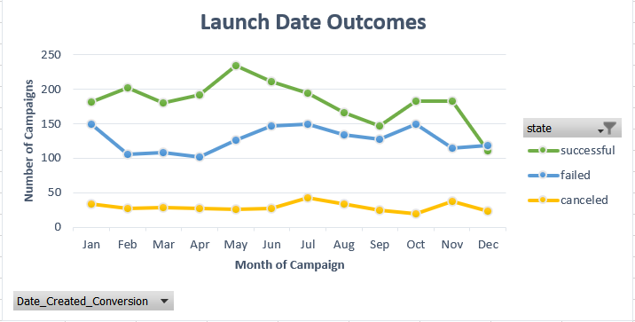

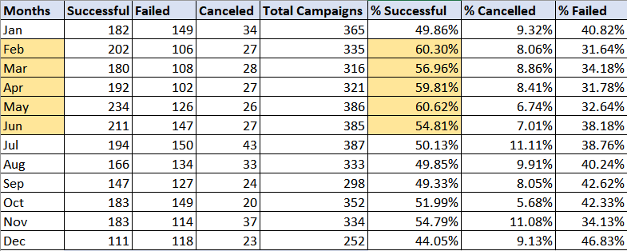

**Limitations of the dataset:**

* The information regarding the money spent by each campaign on the platform towards advertisements and compliments for the backers can help to understand the impact of promotions towards the success of a campaign.
* The dataset hasn’t captured whether the successful campaign has delivered the product.

**Other possible table and/or graphs:**

To identify the interests of the backers, we can create the charts below.

1. By knowing the average donation, we can identify the categories to which has drawn greater interests from the backers.

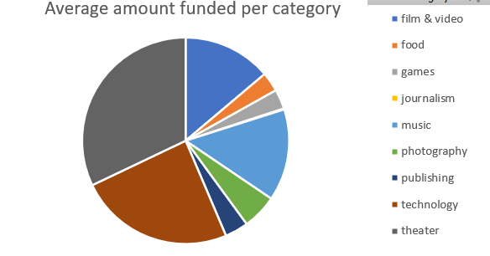

1. A Pivot table/chart can be created with count/average of backers on each category. This can summarize the interests of the backers towards the campaigns in various categories.

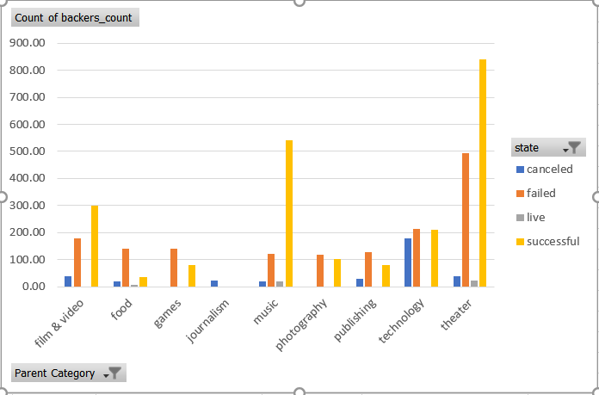

**Statistics summary:**

|  |  |  |  |  |  |  |
| --- | --- | --- | --- | --- | --- | --- |
| **STATISTICS SUMMARY BASED ON BACKERS COUNT** | | | | | | |
| **EVALUATION STATUS** | **Mean** | **Median** | **Minimum** | **Maximum** | **Variance** | **Standard Deviation** |
| **Successful Campaign** | 194.43 | 62 | 1 | 26,457 | 712840.99 | 844.30 |
| **Unsuccessful Campaign** | 17.71 | 4 | 0 | 1,293 | 3773.22 | 61.43 |

**Mean or Median:**

* The below chart shows the distortion of backers count with respect to successful campaigns. Since the data is not normally distributed and has outliers, it would be more appropriate to use Median to summarize the central tendency of the data.
* The mean gets dragged away by few campaigns backed up by bigger count of backers, hence the Median summarizes the data more meaningfully.

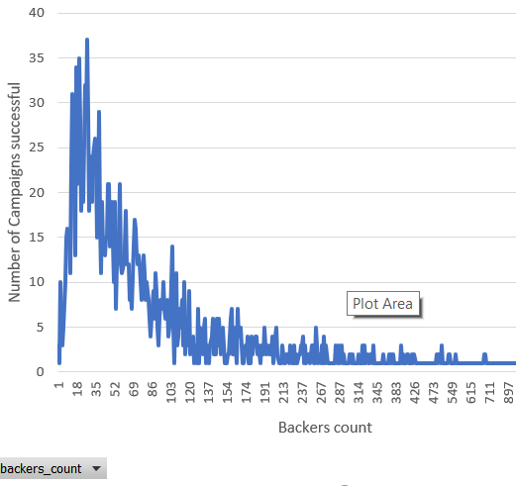

**Variability with campaigns:**

The Variance with successful campaigns is 712840.99 whereas the variability with unsuccessful campaign is 3773.22. This shows, there **is more variability with the successful campaigns**. There are as minimum as 1 backer and maximum of 26,457 backers under successful campaigns which makes the outliers dragging away from the central tendency of the data.